Toyota RAV4 Braking System Supply Chain and Tariff Shock Analysis

# Executive Summary

This report examines the supply chain structure of the Toyota RAV4 braking system for vehicles manufactured in the United Kingdom and quantifies the cost impact of hypothetical tariff shocks on Japanese‐sourced parts. Leveraging database insights, we identify six core components with a combined cost of £458.58 excl. VAT (£550.30 incl. 20% VAT), led by the brake caliper at £240.64. A tariff simulation models three shock scenarios—10%, 30%, and 60%—applied to Japanese imports, revealing limited cost increases of 0.4%, 1.0%, and 1.3%, respectively. Based on these results, the overall impact is classified as **Small**. We supplement the analysis with recent trade news and evaluate alternative suppliers across South Korea, India, Brazil, and China to mitigate Japan‐centric exposure. The findings inform procurement, finance, and operations teams on resilient sourcing strategies, duty‐planning measures, and supplier diversification to manage future trade policy risks effectively.

# Key Points

* Vehicle & Component: Toyota RAV4 braking system
* Combined Price: £458.58 excl. VAT / £550.30 incl. 20% VAT
* Tariff Scenarios: 10%, 30%, 60% on parts imported from Japan
* High-Level Impact: Small impact—1.3% increase in total braking system spend

# Component Analysis

The Toyota RAV4 braking system comprises six distinct parts with a total pre-VAT cost of £458.58 (post-VAT £550.30). The highest-value item is the brake caliper at £240.64, representing 52.48% of system cost. All six parts are subject to UK VAT at 20%. Geographic origin is concentrated in Germany (19 articles), Denmark (17), and the Netherlands (17), together accounting for 75% of sourcing volume. Supplier diversity is moderate: the broader network includes 83 suppliers, with the top three (DELPHI, A.B.S., and KAVO PARTS) responsible for 25 of 70 total articles (35.7% share), indicating some concentration risk amid a reasonably broad base.

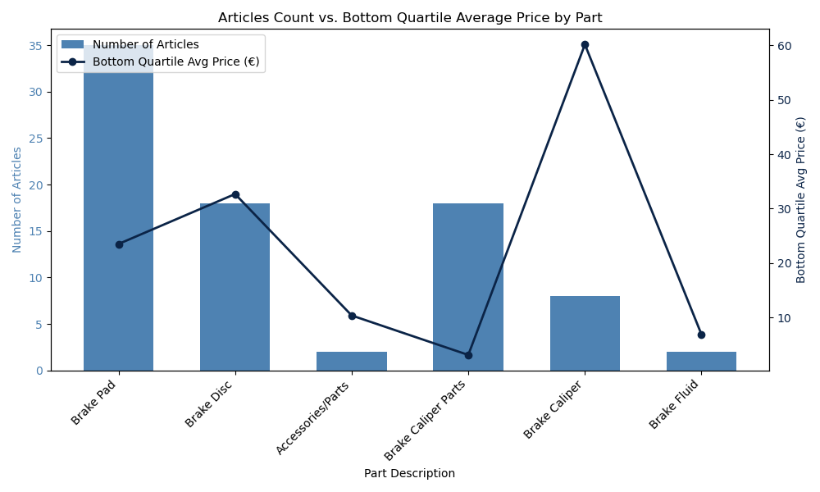

Figure: CA_combination_chart_articles_count_and_bottom_quartile_avg_price_per_part

CA_combination_chart_articles_count_and_bottom_quartile_avg_price_per_part

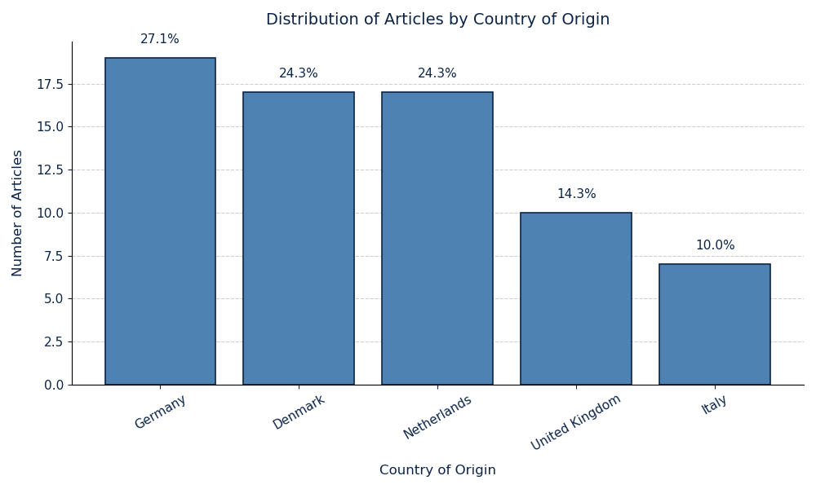

Figure: CA_bar_chart_articles_distribution_by_country_of_origin

CA_bar_chart_articles_distribution_by_country_of_origin

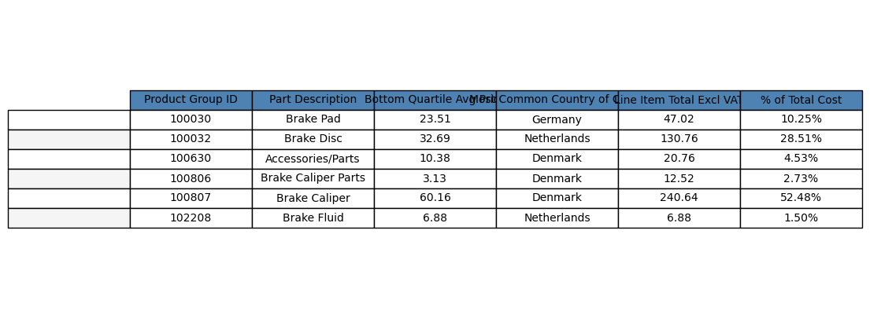

Figure: CA_table_summary_parts_with_pricing_origin_and_cost_breakdown

CA_table_summary_parts_with_pricing_origin_and_cost_breakdown

* Top 3 Parts by Cost: Brake Caliper (£240.64, 52.48%), Brake Disc (£130.76, 28.51%), Brake Pad (£47.02, 10.25%)
* Top 3 Suppliers by Article Count: DELPHI (10 articles), A.B.S. (10 articles), KAVO PARTS (5 articles)

# Tariff Simulation

We model three tariff shock scenarios (10%, 30%, 60%) on parts imported from Japan, representing 6 of 6 total articles (100% exposure). Post-shock, UK VAT at 20% is applied to the sum of base and tariff duties. The current duty rate on Japanese brake parts stands at 1.25%, yielding a baseline total cost of £557.18 (including £5.73 duties and £92.86 VAT). Even under a high-shock 60% tariff, total system cost rises modestly to £564.42, an absolute increase of £7.23 (1.3%). This reflects limited financial vulnerability to sudden UK tariff hikes on these components.

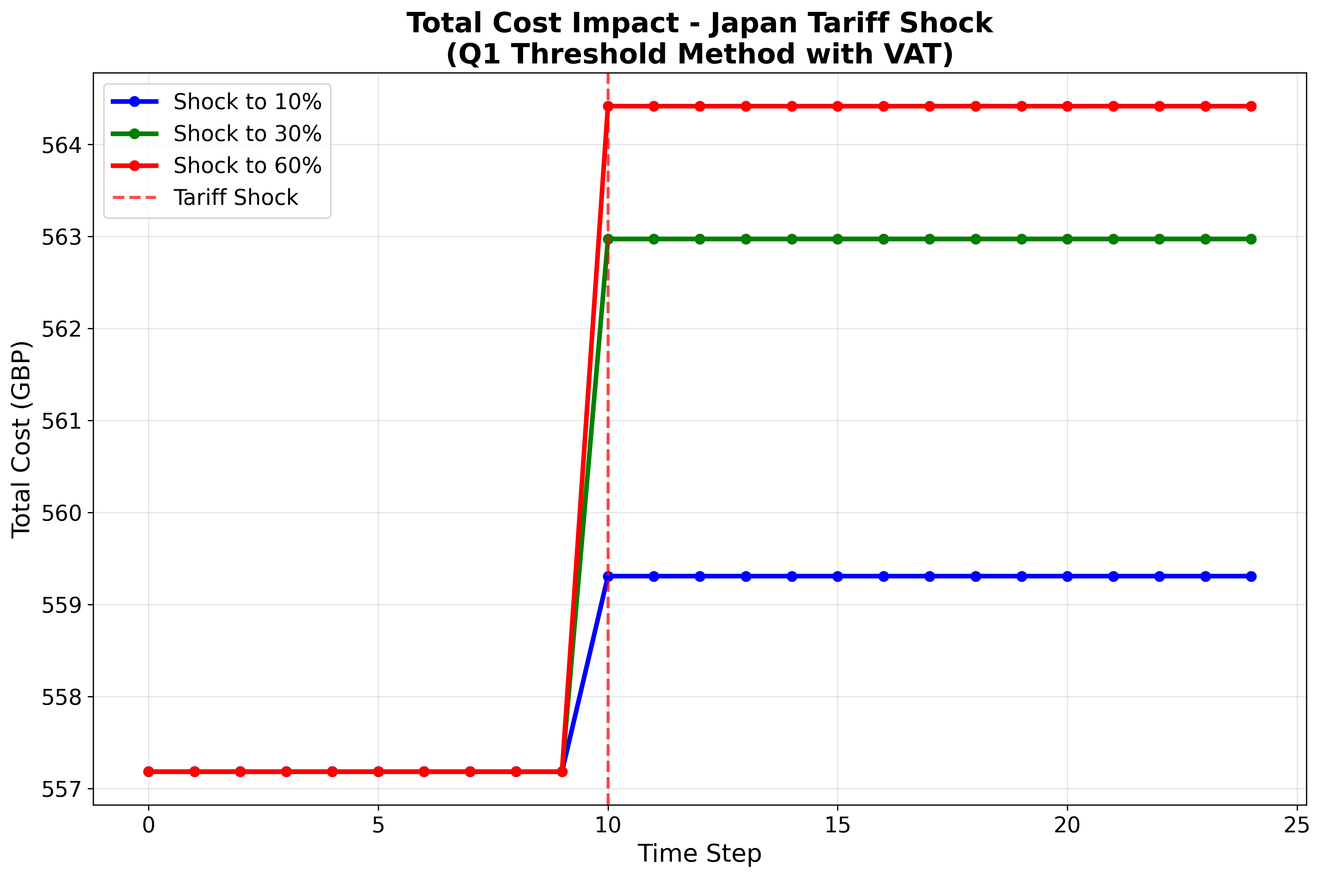

Figure: cost_progression_q1_method_japan_20250930_170246

cost_progression_q1_method_japan_20250930_170246

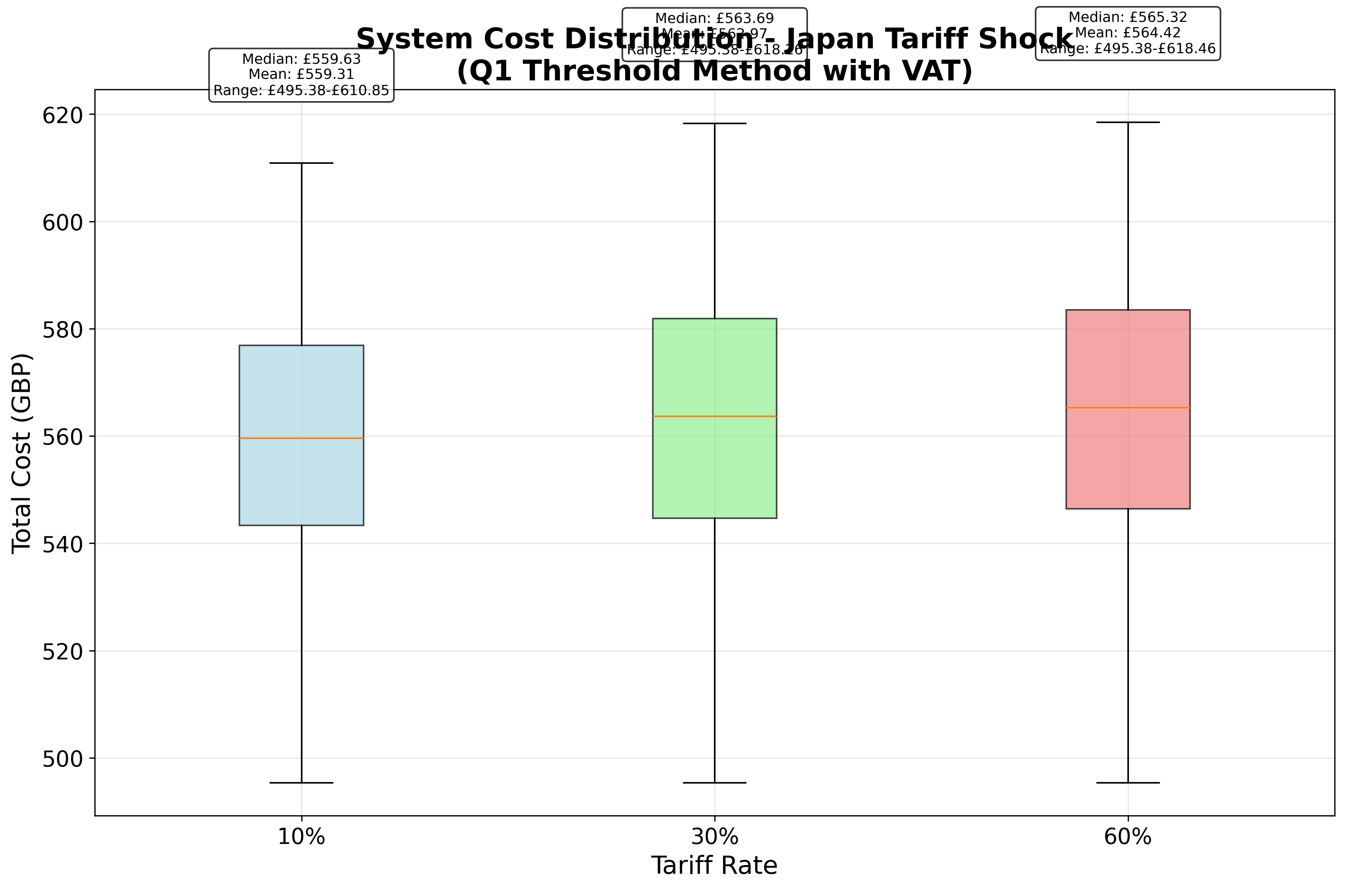

Figure: system_cost_distribution_q1_method_japan_20250930_170246

system_cost_distribution_q1_method_japan_20250930_170246

* Pre-Shock Cost Breakdown: Base £458.59, Tariff £5.73, VAT £92.86, Total £557.18
* 10% Tariff: Initial £557.18 → £559.31, +£2.13 (+0.4%)
* 30% Tariff: Initial £557.18 → £562.97, +£5.79 (+1.0%)
* 60% Tariff: Initial £557.18 → £564.42, +£7.23 (+1.3%)

# Tariff News

Recent trade developments indicate evolving tensions and negotiations impacting Japanese automotive exports. In early September 2025, U.S. tariffs on Japanese goods—including cars and components—were formally reduced to 15% under an executive order, down from prior rates up to 27.5% [1][2]. Concurrently, the U.S. Commerce Department proposed new national security tariffs on over 400 auto-related products, encompassing exhaust systems and electrical steel, underscoring looming protectionist risks in major markets [3]. While these measures primarily affect U.S.-Japan dynamics, they signal potential global tariff realignments that UK procurement teams should monitor, as similar protectionist pressures could extend to British trade policy post-Brexit.

# Alternative Suppliers

To reduce reliance on Japanese sources, alternative suppliers have been identified across key regions. South Korea offers OEM-certified calipers, pads, and discs via TheSparePartShop.com, with IATF 16949 certification, lead times of 7–20 days, and MOQs of 10–50 units [4]. In India, Brake Parts India Pvt. Ltd. delivers pads and discs at competitive price points (e.g., INR 46/unit), ISO/IATF-certified, with 10–20 day lead times and 25–100 unit MOQs [5]. Brazil’s Brake Parts Inc Brazil supplies friction materials and hydraulic components, ISO-certified, 14–30 day lead times, and 20+ unit MOQs [7]. China’s Alpha Brakes produces OEM-grade pads at $1.80–$2.30 per set (MOQ 50 sets, 10–15 day lead) under TS16949 and E-MARK standards [6]. These non-Japanese sources provide capacity, quality credentials, and cost advantages when local tariffs or trade disruptions arise.

# Impact Assessment

Based on the tariff simulation, the most severe scenario (60% tariff) generates only a 1.3% increase in total system cost. This falls well below the 5% threshold, classifying the impact as **Small**.

# Recommendations

* Diversify the supplier base across South Korea, India, Brazil, and China to mitigate Japan-centric risk.
* Leverage bonded warehousing or inward processing relief to defer VAT and duty liabilities.
* Implement real-time digital monitoring of tariff announcements and trade policy shifts.
* Negotiate long-term supply contracts with tariff-indexation clauses to stabilize costs.
* Explore localized sub-assembly partnerships or near-shoring within the UK/EU to reduce exposure.

# References

* [1] US tariffs on Japanese goods to be cut by Sept 16, Japan's Akazawa says on X: https://www.reuters.com/business/autos-transportation/us-tariffs-japanese-goods-be-cut-by-sept-16-japans-akazawa-says-x-2025-09-08/
* [2] Exclusive: Japan, US near deal to bring lower auto tariffs into effect, source says: https://www.reuters.com/business/japan-us-near-deal-bring-lower-auto-tariffs-into-effect-source-says-2025-09-04/
* [3] US to consider new national security tariffs on auto parts: https://www.reuters.com/business/autos-transportation/us-consider-new-national-security-tariffs-auto-parts-2025-09-16/
* [4] TheSparePartShop.com – Genuine RAV4 brake parts in South Korea: https://www.thesparepartshop.com/south-korea/genuine/toyota/braking-system/parts-dealers.php
* [5] Brake Parts India Pvt. Ltd. (BPI) – Product portfolio and certifications: https://www.brakepartsinc.com/Brake-Parts-India.html
* [6] Alpha Brakes – OEM‐certified brake pads (China): https://www.alphabrakes.com/brake-pad-toyota/
* [7] Brake Parts Inc Brazil Division – OEM and aftermarket components: https://www.brakepartsinc.com/en_BR/